**Human detection and alert the system**

1stHaripriya M 2nd Balaji K G 3rd Kuladeep T

*Computer Science Department Computer science Department Computer science Department*

*MITS MITS MITS*

Nandyala, India Amarapuram(m), India Madanapalle, India

haripriya1610546@gmail.com balajikghlk@gmail.com Kuladeep098@gmail.com

***Abstract*—** The content uses the YOLOv3 (You Just Look Once rendition 3) a profound brain network for continuous human location in a webcam feed. It utilizes OpenCV for picture handling and Pygame for playing an alarm sound when human is identified. The Just go for it model is stacked with pre-prepared loads, and the content cycles video outlines, distinguishes people with a certainty limit, and draws jumping boxes around them. Moreover, a multithreading approach is utilized to play an alarm sound simultaneously with human location. The variety coded bouncing boxes and certainty marks improve the visual portrayal of recognized people.Or on the other hand

In late headways in PC vision, the YOLOv3 (You Just Look Once variant 3) profound brain network has arisen as an incredible asset for ongoing human location in webcam takes care of. This content outfits the abilities of YOLOv3, utilizing OpenCV for picture handling and Pygame to consolidate an alarm sound after recognizing people. The usage of pre-prepared loads improves the productivity of the Consequences be damned model, permitting the content to handle video outlines, distinguish people in light of a certainty edge, and depict their presence with bouncing boxes.

To additional improve the client experience, a multithreading approach has been executed, guaranteeing that the alarm sound plays simultaneously with human location. The variety coded bouncing boxes and certainty marks add to an enhanced visual portrayal of the identified people, giving lucidity and interpretability.

This work not just fills in as a commonsense execution of YOLOv3 yet in addition underscores the more extensive ramifications and roads for investigation in the field of continuous human recognition. The requirement for progressions in space explicit applications, strength, moral contemplations, joining with sensor organizations, and ongoing execution streamlining is featured. The content's far reaching outline plans to direct future examination tries, giving an establishment to the persistent development of YOLOv3 and its effect on improving wellbeing and security through exact human identification across different spaces.

**INTRODUCTION**

In 2016, Redmon, Divvala, Girschick, and Farhadi distributed a "You Just See Once: Bound together Constant Item Discovery," which changed the field of article location. He presented another hunt strategy in which highlight extraction and item situating are consolidated into an entire block. Moreover, territorial and division supervisors have been consolidated. Their single-stage engineering, called Consequences be damned (You Just Look Once), has an exceptionally quick runtime. On the Titan It came to 150fps in light of the fact that the web was little and less delicate. This new methodology, along with different apparatuses created by the lightweight Google Mobile-Net Center, conveys the vision (objective) of distinguishing networks and other life-like CV exercises at the edge of gear.

Thought behind Consequences be damned With every there is no grouping/disclosure module that should be synchronized and there is no local rehashing circle like past 2-stage locators (see my article on more seasoned items like RCNN). This is a totally basic convolution (with max-pool layer). A comprehensive organization alone ought to deal with extraction, relapse box, and order; not handling regions where items are probably going to be found and taking care of them into the hunt box organization. While past models had two result layers, one for class order and the other for box expectation, here one result layer contains everything with various elements.

**LITERATURE QUESTIONNAIRE:**

**A. Related Works:**

The literature surrounding YOLOv3 and real-time human detection encompasses several key works that have significantly contributed to the understanding, development, and application of YOLOv3. Notable works include the seminal paper "You Only Look Once: Unified, Real-Time Human Detection" by Redmon, Divvala, Girschick, and Farhadi (2016), which introduced the YOLO architecture, revolutionizing the field of human detection by unifying feature extraction and human positioning into a single-stage architecture. This work laid the foundation for subsequent research and development in the area of real-time human detection.

Additionally, studies such as "A review of human detection based on convolutional neural network" by W. Zhiqiang and L. Jun (2017) and "A review on YOLO (You Look Only One)-an algorithm for real-time object detection" by Arya MC and Rawat A (2020) provide comprehensive insights into the evolution of object detection methods, with a specific focus on YOLO and its unique approach to real-time object detection.

Furthermore, recent advancements such as "PP-YOLO: An effective and efficient implementation of human detector" by Xiang Long et al. (2020) and "Apple detection during different growth stages in orchards using the improved YOLO-V3 model" by Yunong Tian et al. (2019) highlight the ongoing developments and applications of YOLOv3 in diverse domains, showcasing its adaptability and versatility.

**B. Gaps in research:**

Despite significant advances in YOLOv3 and real-time object detection, there are several research gaps that require further investigation. These include:

1. Domain-specific applications: While YOLOv3 has beenapplied in various domains, there is a need for in-depth studies focused on domain-specific applications such as medical imaging, agricultural automation, and industrial security. Understanding the nuances of YOLOv3 in these specific areas can lead to tailored solutions and improvements.
2. Robustness and generalizability: Research aimed at in-creasing the robustness and generalizability of YOLOv3 in different environmental conditions, lighting scenarios and object orientations is essential. Addressing these factors can improve the reliability and usability of YOLOv3 in the real world.
3. Ethical and Privacy Aspects: With the increasing adoptionof human detection systems in surveillance and security applications, there is a need for research that addresses the ethical and privacy aspects associated with the use of YOLOv3 and similar technologies.
4. Integration with sensor networks: Exploring the integra-tion of YOLOv3 with sensor networks and IoT devices for improved human detection and situational awareness is an area for further investigation.
5. Real-time performance optimization: Research into real-time performance optimization of YOLOv3, especially in resource-constrained environments, can lead to advances in edge computing and embedded systems.

Addressing these research gaps can contribute to the continued development and improvement of YOLOv3, further enhancing its capabilities and applicability in various fields.

**III. MATERIALS AND METHODS:**

**A. Description of the data:**

YOLOv3 or You Only Look Once version 3 is a popular object detection algorithm known for its speed and accuracy in detecting objects in images and videos. It works by dividing the input image into a grid and predicting bounding boxes and class probabilities for each grid cell. Unlike traditional object detection methods that use sliding windows or region design techniques, YOLOv3 performs detection in a single pass of a neural network, enabling real-time performance even on resource-constrained devices. The model architecture consists of a convolutional neural network (CNN) The backbone is usually based on a pre-trained network such as Darknet53, followed by a detection layer responsible for predicting bounding boxes and class probabilities. YOLOv3 is trained on a large dataset containing annotated images with different object categories, which allows it to generalize well to a wide variety of objects and scenes. Efficient inference speed and high accuracy make YOLOv3 a solution for various applications, including surveillance, autonomous driving, and object detection in real-world scenarios.

Commonly known as You Only Look Once or YOLO, this algorithm is part of the R-CNN family (R-CNN, Fast R-CNN, Faster R-CNN, etc.).

The R-CNN family of algorithms use regions to locate objects in images. This means that the model is applied to several regions, and regions with high image scores are considered as detected objects. But YOLO has a completely different approach. Instead of selecting some regions, a neural network is applied to the entire image to predict bounding boxes and their probabilities.

• There are two options to start object detection:

1. Using pre-trained models
2. Train a custom object detector from scratch

Consider building an object detector using pre-trained models to recognize humans and your system’s webcam.

1. *Entering data:*

You also need to download some heavy files including YoloV3 pre-trained weights, configuration file and name file. Yolov3.Weights and yolov3.cfg (or configuration) files can be downloaded from https://pjreddie.com/darknet/yolo. In these websites you can get all the details about yolov3. Since live streaming and alarm sounds are intended for this purpose, the Mixkit-classic-shorr-alarm-993.Wa dataset is used to get the alarm sound for that location and can be downloaded from

Mixkit.

1. *Data:*

cfg file. An essential component to setting up the architecture is specifying network parameters and configuring other aspects of the YOLOv3 model. Below is an overview of the main sections commonly found in YOLOv3.

TABLE I

|  |  |  |
| --- | --- | --- |
| Section | *Parameter* | *Values* |
| Test | Bulk | 1 |
|  | Segmentation | 1 |
| Education | Width | 416 |
|  | Height | 416 |
|  | Channel | 3 |
|  | Momentum | 0.9 |
|  | Attenuation | 0.0005 |
|  | Angle | 0 |
|  | Saturation | 1.5 |
|  | Exposure | 1.5 |
|  | Hue | 0.1 |
|  | Learning rate | 0.001 |
|  | Burn in rate | 1000 |
|  | Max batches | 500200 |
|  | Policy | steps |
|  | steps | 400000,450000 |
|  | Scales | 0.1,0.1 |
| Convolution | Batch normalize | 1 |
|  | Filters | 32 |
|  | Size | 3 |
|  | Stride | 1 |
|  | Pad | 1 |
|  | Activation | Leaky |
| Yolo (multiple layers) | mask | 0,1,2 |
|  | Anchors | 10,13,16,30,33,23,30,61,62,45,  59,119,116,90,156,198,373,326 |
|  | Classes | 80 |
|  | Num | 9 |
|  | Jitter | 0.3 |
|  | Ignore thresh | 0.7 |
|  | Truth thresh | 1 |
|  | Random | 1 |

* 1. **IMPLEMENTATION OF THE MODEL:**

Carrying out YOLOv3 for human acknowledgment includes a few significant stages. In the first place, the YOLOv3 design characterized in the arrangement document (yolov3.cfg) is stacked with pre-prepared loads (yolov3.weights). These loads catch information gained from huge datasets and increment the speculation capacity of the model. The information picture or video transfer is then handled through the organization, partitioned into matrices, and bouncing boxes, class probabilities, and human body certainty scores are anticipated. Use post-handling methods, for example, non-maximal concealment to refine expectations and eliminate excess jumping boxes. The whole cycle is acted progressively, showing the proficiency of YOLOv3 in human acknowledgment undertakings. Execution additionally incorporates tweaking hyperparameters, setting certainty limits, and adjusting the model to explicit use cases. Reconciliation into applications for the most part requires interacting with structures like Darknet, TensorFlow, or PyTorch. This empowers consistent organization of YOLOv3 for human discovery in different situations including video observation, wellbeing checking and human-driven applications.

Profound Brain Organization:

Human identification with YOLOv3 utilizes profound brain organizations to precisely distinguish and find people in a picture or video outline. YOLOv3 models are organized with convolution layers, remaining blocks, and anchor boxes to handle data at different scales productively. The information picture is separated into networks, and every matrix cell is liable for anticipating the human jumping box, class likelihood, and item certainty score. YOLOv3 predicts in three scales and obliges objects of various sizes. During preparing, the model is enhanced through backpropagation to limit restriction misfortune, characterization misfortune, and certainty misfortune. Surmising includes a constant cycle wherein the organization makes expectations in a solitary pass, making it reasonable for applications that require quick and precise human acknowledgment, like video observation and human-PC collaboration. The post-handling step incorporates non-maximal concealment, pre-bouncing box change

* 1. **RESULTS AND DISCUSSION:**

The developed monitor was implemented on pychram using opencv, pygame and numpy. PyCharm is an integrated development environment (IDE) used for programming in Python. Provides code analysis and a graphical debugger.

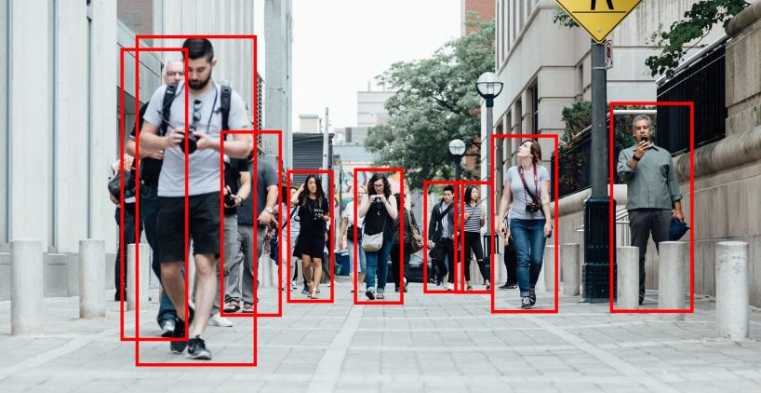

## Fig.1: Human/People Detection

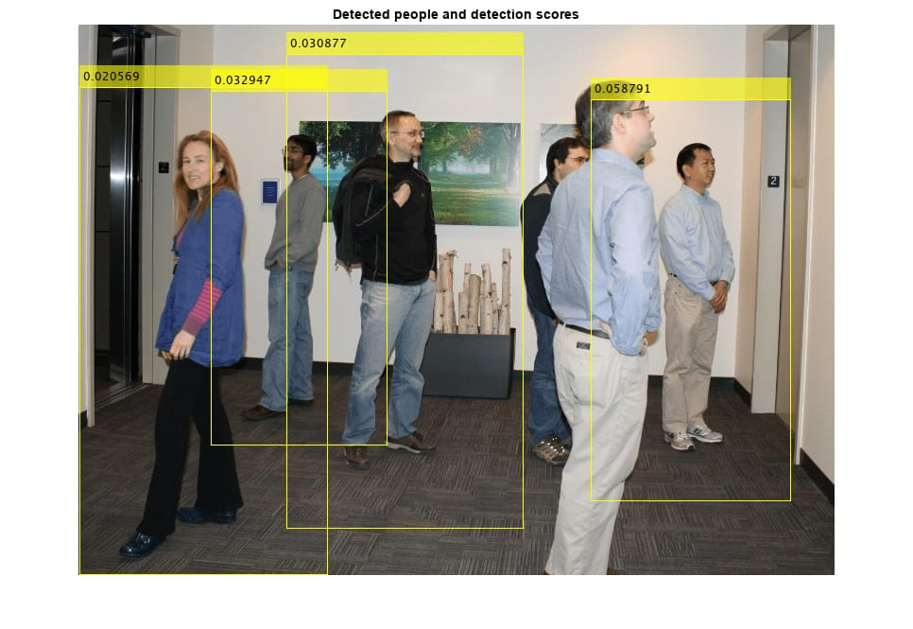

## Fig.2: Peoples Detection with Scores

* 1. **CONCLUSION:**

the computerization of the proposed framework has demonstrated to be a more productive, viable, and exact group the board arrangement when contrasted with manual tasks. Regardless of the equipment

impediments, this study has accomplished the genuine continuous execution with an extra quicker YOLOv3-small model. Moreover, it accomplishes a high fixing exactness of 91.07% with the typical YOLOv3 model. The show of exact profound learning

YOLOv3 and DeepSORT calculations has settled normal challenges in human discovery and counting like different camera direction, individuals thickness, lighting, and impediment. The exceptional commitment of this proposed framework contrasted with existing and comparative frameworks is the immediate similarity with existing reconnaissance Camera without new equipment or space occupation prerequisites. In expansion, an easy to understand and beginner GUI is utilized to design, run, search, and playback the human discovery and then some. Furthermore, the

solid benefits of involving GPU for PC vision applications furthermore, changing over pretrained YOLOv3 model into TensorFlow configuration from unique weight and arrangement documents for considerably quicker

handling are demonstrated. The fundamental impediment of the proposed framework is low goal in specific testing recordings where human articles are hazy and hard to be recognized particularly while utilizing the YOLOv3-little model. Moreover, the Google TensorFlow configuration is just right now upheld by Nvidia GPU machines with Python execution. At last, the proposed framework actually has enormous room of enhancements where a much more exact YOLOv3 discovery could be added with the objective width and level set at 608 if a superior GPU determination is accessible. GPU is as of now not an, truth be told costly necessity with Nvidia delivering their reasonable Jetson Nano series, which is essentially a little yet strong PC with committed GPU specific for handling in PC vision applications. This innovation accessibility doesn't just save the expense of buying a total PC set for facilitating yet additionally incredibly diminishes the space occupation for such framework to be effectively conveyed in genuine climate. Besides, an extra AI calculation can likewise be incorporated to continually adjust and learn new human articles distinguished in the arrangement climate; subsequently, it further works on the exactness.

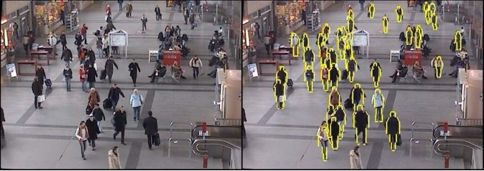

## Fig. 3: The Human detection using opencv

**ACKNOWLEDGMENT**

Human discovery and alert affirmation are essential to guarantee security in many spots. Utilizing progressed discovery advances, for example, infrared sensors, movement finders and cameras, the framework can recognize the presence of individuals in the observed region. The utilization of gadgets demonstrates dependability, while dynamic calculations dissect circumstances to decide the need to set off a caution. At the point when the recognition is right, the situation produces a prompt caution through alert, visual alarm, or correspondence like SMS or email. Coordinate with other security frameworks and interface with different stages for a bound together and responsive interaction. While the UI makes due, put together and survey authentic information, support and streamlining endeavors assist with keeping up with effectiveness in the long haul. Because of this mix, human location and alert assume a significant part in forestalling unlawful and possibly risky mediations.

**REFERENCES**

1. Redmon, Joseph et al. ”One Look: Integrated Real-Time Object Recognition”. 2016.
2. W. doi: 10.23919/ChiCC.2017.8029130 DOI: https://doi.org/10.23919/ChiCC.2017.8029130
3. Arya MC, Rawat A. An overview of YOLO (You Look Only One), a real-time object detection algorithm. J Eng Sci. 2020; 11:554-7
4. Arya, Mukesh Chandra, Anchal Rawat. ”Review of the YOLO (You Only Look Like One) Real-Time Object Recognition Algorithm” J Eng Sci 11 (2020): 554-7.
5. Redmon et al. ”You only look once: integrated real-time object detection.” Proceedings of the IEEE Conference on Computer Vision and Pattern Recognition. 2016.
6. Tsang, Sikoho. ”Review: YOLOv2 and YOLO9000 — You only look once (object detection) (accessed 24 February 2019) (2019) u Only One One Look: Unified Real-Time Object Detection
7. M. Takahashi, Y. Ji, K. Umeda, and A. Moro, ”Scalable YOLO: 3D object recognition from RGB-D images”, 2020 21st International Conference on Research and Education in Mechatronics (REM), 2020, pp. 1-5, doi: 10.1109/REM49740.2020.9313886. DOI: https://doi.org/10.1109/REM49740.2020.9313886
8. Joe, M. Lu, H. Wang, Z. Hui, B. Chang, Z. Improved application of YOLO V3 in multiscale target detection. Applied Sciences. 2019, 9, 3775. DOI: https://doi.org/10.3390/app9183775
9. Wei Fang 1,2, (Member, ieee), Lin Wang 1, and Peiming Ren 1, ”Tinier-YOLO: A real-time object detection method for constrained

environments.”

1. Yi, Zhang, Shen Yongliang, and Zhang Jun. ”Improved small-yolov3 pedestrian detection algorithm” Optik 183 (2019): 17-23. FANG 1,2, (Member, IEEE), Lin Wang 1, and Peiming Ren 1, “Tinier-YOLO: A real-time object detection method for constrained environments. DOI: https://doi.org/10.1016/j .ijleo.2019.02.038
2. Tian, Yunong, et al. ”Detection of Apples at Different Growth Stages in Orchards Using the Improved YOLO-V3 Model.” Computers and Electronics in Agriculture 157 (2019): 417-426 DOI:

https://doi.org/10.1016/j.compag.2019.01.012

1. Arya MC, Rawat A. A review on YOLO (You Look Only One)-an algorithm for real time object detection. J Eng Sci. 2020;11:554-7 An academic article has been written to discuss YOLO, an algorithm that enables real-time object detection. The article explores the capabilities of YOLO and its impact on object detection in different scenarios. The authors analyze the advantages and limitations of this algorithm.
2. M. Takahashi, Y. Ji, K. Umeda and A. Moro, ”Expandable YOLO: 3D Object Detection from RGB-D Images,” 2020 21st International Conference on Research and Education in Mechatronics (REM), 2020, pp. 1-5, doi: 10.1109/REM49740.2020.9313886. DOI: Doi: 10.1109/REM49740.2020.9313886 This article presents a novel approach called Expandable YOLO for 3D object detection using RGB-D images. The authors propose an expandable architecture that leverages depth information to improve detection accuracy. Experimental results demonstrate the effectiveness of the proposed method. The researchers introduce a real-time object detection method called Tinier-YOLO, designed specifically for constrained environments. The paper presents the architecture and implementation details of the TinierYOLO model, highlighting its efficiency in detecting objects accurately under resource-constrained conditions.
3. Yi, Zhang, Shen Yongliang, and Zhang Jun. ”An improved tiny-yolov3 pedestrian detection algorithm.” Optik 183 (2019): 17-23.FANG 1,2, (Member, IEEE), lin wang 1, and peiming ren 1, ”Tinier-YOLO: A RealTime Object Detection Method for Constrained Environments. DOI: Doi: 10.1016/j.ijleo.2019.02.038 This article presents an improved version of the Tiny-YOLOv3 algorithm specifically for pedestrian detection. The authors propose modifications to the original algorithm to enhance its performance in detecting pedestrians accurately. Experimental results demonstrate the effectiveness of the proposed improvements.
4. George, Jose, Shibon Skaria, and V. V. Varun. ”Using YOLO based deep learning network for real time detection and localization of lung nodules from low dose CT scans.” Medical Imaging 2018: ComputerAided Diagnosis. Vol. 10575. SPIE, 2018.madJavad,et,al

[16] Santosh Divvala, Redmon, Joseph, Ross Girshick, and Ali Farhadi. "You only look once: Unified, real-time object detection." In Proceedings of the IEEE conference on computer vision and pattern recognition, pp. 779-788. 2016

[17]. Wong, Alexander, et al. "Yolo nano: a highly compact you only look once convolutional neural network for object detection." 2019 Fifth Workshop on Energy Efficient Machine Learning and Cognitive Computing-NeurIPS Edition (EMC2-NIPS). IEEE, 2019,DOI:https://doi.org/10.1109/EMC2-NIPS53020.2019.00013

[18] .Wei H, Kehtarnavaz N (2019) Semi-supervised faster RCNN-based person detection and load classification for far field video surveillance. Mach Learn Knowl Extraction 1(3):756–767 DOI: https://doi.org/10.3390/make1030044

[19] Tsang S-H (2018) Review: Inception-v4 - Evolved From GoogLeNet, Merged with ResNet Idea (Image Classification), towards data science.